**Ideation Phase**

**Define the Problem Statements**

| Date | 18 June 2025 |
| --- | --- |
| Team ID | LTVIP2025TMID30187 |
| Project Name | Optimizing User, Group, and Role Management with Access Control and Workflows |
| Mentor Name | Dr Shaik Salma Begum |
| Maximum Marks | 4 Marks |

### Customer Problem Statement:

**Who is the customer?**

The primary customers are small project management teams that need a clear, structured, and automated way to manage roles, access permissions, and task workflows efficiently. In this context, a typical team includes a Project Manager and one or more Team Members.

**What is the problem?**

Small teams often face the following issues:

* Undefined roles and responsibilities leading to confusion in task ownership.

∙ No clear access control, resulting in unauthorized or mistaken task edits.

* Lack of workflow structure, making task progress tracking difficult.
* Absence of accountability mechanisms and activity visibility.

**Why is this problem important to solve?**

Without proper user-role management and workflows, teams experience:

∙ Reduced productivity and increased project delays.

∙ Poor communication and unclear accountability.

∙ Errors in task assignments and project tracking.

∙ Difficulty scaling or onboarding new team members effectively.

**How does the customer currently address this problem?**

Most small teams rely on ad-hoc solutions like email, spreadsheets, or generic task boards. These tools lack built-in access control, structured workflows, or visibility into task ownership and accountability.

**What is the desired outcome?**

A centralized, automated, and role-based task management system that:  
  
- Defines and enforces roles and responsibilities (e.g., Project Manager vs. Team Member).  
- Implements access controls for secure task assignment and editing.  
- Provides a defined task workflow with status tracking and approvals.  
- Supports activity logging and real-time notifications for accountability.  
- Enables scalability and onboarding with minimal confusion.

* Allows families to record, categorize, and link expenses easily.
* Provides real-time insights into spending patterns.
* Generates automated identifiers and reports for better tracking.
* Issues alerts when budgets are exceeded to prevent overspending.
* Simplifies the financial management process with a user-friendly interface.

**Empathy and Customer Viewpoint**

By focusing on these needs, the solution aims to empower families with tools that not only simplify expense tracking but also promote financial discipline, better planning, and peace of mind.

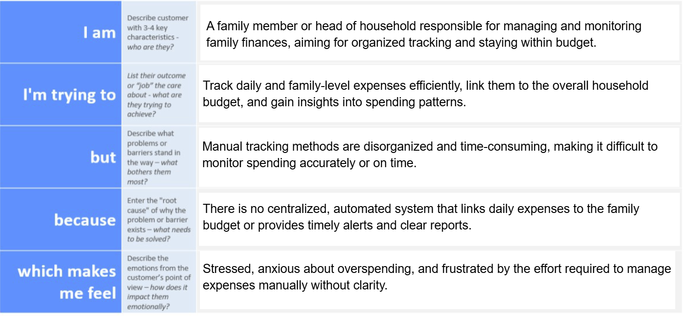

| **Problem Statement (PS)** | **I am (Customer)** | **I’m trying to** | **But** | **Because** | **Which makes me feel** |
| --- | --- | --- | --- | --- | --- |
| PS-1 | |  | | --- |  | Family member /  parent | | --- | | Record and track daily expenses | | I often miss entries | | --- |  |  | | --- | | There’s no centralized system | Disorganized and uncertain |
| PS-2 | Family head / budget owner | Stay within a monthly household budget | I don’t get alerts on overspend | |  | | --- |  | No automated  budget tracking | | --- | | Worried and reactive |
| PS-3 | Family member | |  | | --- |  | Link daily  expenses  to household  spending | | --- | | It’s difficult to consolidate | Records are stored separately | Confused and overwhelmed |
| PS-4 | |  | | --- |  | Financial  planner  (for family) | | --- | | Analyze spending patterns | |  | | --- |  | I lack categorized  reports | | --- | | |  | | --- |  | No reporting  functionality | | --- | | Uninformed and unsupported |
| PS-5 | |  | | --- |  | Tech-savvy  family member | | --- | | Manage expense records efficiently | |  | | --- |  | Data entry is slow  and manual | | --- | | No custom forms or automation | Frustrated and inefficient |

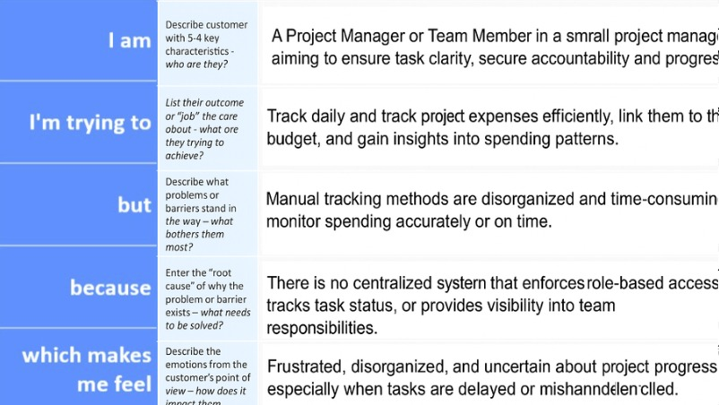

| I am (Customer) | I’m trying to | But | Because | Which makes me feel |
| --- | --- | --- | --- | --- |
| Project Manager (Alice) | Assign and monitor project tasks | Team members edit or ignore assignments | There is no role-based access control | Frustrated and powerless |
| Team Member (Bob) | View and update only my assigned tasks | I can see or edit tasks not meant for me | No proper user permissions defined | Confused and overwhelmed |
| Project Manager (Alice) | Track progress through task workflow | Tasks skip steps or lack accountability | No structured or enforced workflow | Uncertain and stressed |
| Team Member (Bob) | Understand my responsibilities clearly | I receive unclear or overlapping tasks | No role definition or assignment rules | Lost and disengaged |
| Project Manager (Alice) | Approve completed tasks reliably | Some tasks are marked done without review | Missing approval steps in the workflow | Concerned and reactive |